I. Definition and Scope

Subaerial tsunami deposits are those geologic materials (including grain sizes from boulders to mud) deposited above mean sea level during the passage of a tsunami. The material may come from offshore, or may be reworked material from onshore. Modern tsunami deposits have been used to help establish the landward limit of inundation (Figure 1) and the direction water flowed over an area, but tsunami deposits are most often used to infer the passage of prehistoric tsunamis.
Prehistoric tsunamis have been identified solely on the basis of their deposits in the Pacific Northwest (Atwater and Moore, 1992; Benson et al., 1997), Kamchatka (Pinegina and Bourgeois, 2001; Pinegina et al., 2003), Japan (Nanayama et al., 2003), the North Sea (Dawson et al., 1988), and Hawaii (Moore, 2000; Moore et al., 1994), among others. These studies have helped scientists and disaster managers understand the tsunami risk associated with not only these areas, but also other areas in the same ocean basin. In regions where tsunamis are infrequent, paleotsunami deposits may represent the only available means of determining the magnitude and frequency of tsunamis (and associated seismic events).
To be an effective tool for hazard planning, however, we must understand how to recognize and interpret paleotsunami deposits. Although attempts to “codify” the criteria for paleotsunami deposit recognition have been made (e.g. Chagué-Goff and Goff, 1999; Nanayama et al., 2000; Tuttle et al., 2004), there remains no clear means of distinguishing tsunami deposits from the deposits of other coastal phenomena such as storms. This difficulty has led to vigorous debate on the origin of several published paleotsunami deposits (e.g. Bryant et al., 1992; Hearty, 1997; Moore and Moore, 1984).
Another complication in interpreting paleotsunami deposits is the lack of information on what changes in lateral extent, thickness, and internal structure a tsunami deposit undergoes from deposition to observation. This is of concern in part because we use modern tsunami deposits as a model for what ancient tsunami deposits “should” look like. However, if significant changes to the deposit have occurred, we need to understand how those changes might affect what ancient deposits might look like. Moreover, any attempt to interpret the deposits of ancient tsunamis will necessarily entail looking at the landward extent of deposition, the thickness of the deposit, the internal structure of the deposit, or some combination of these. Without a clear understanding of what changes (if any) a deposit undergoes between deposition and observation, we cannot estimate even such basic parameters as inundation distance with any degree of precision.
Tsunami deposits also have the potential to record the flow parameters of the waves that created them—although several attempts to estimate wave parameters from tsunami deposits have been made (e.g. Moore and Mohrig, 1994; Nott, 1997; Reinhart, 1991), this subject is still in its infancy. This emerging field has, however, the potential to help assess the risk posed not only by tsunamis, but also by the earthquakes that generate them. In many cases, tsunami deposits are the only record not only of ancient tsunamis, but also of prehistoric earthquakes. In these cases, information on tsunami size over a section of coast can be used to place constraints on the location and nature of earthquake rupture (e.g. Tanioka and Satake, 2001).
We perceive, then, three major gaps in our knowledge of tsunami deposits:

- Criteria for distinguishing tsunami deposits from the deposits of other coastal phenomena
- Understanding of the changes that take place in tsunami deposits between the time they are deposited and the time they are discovered
- understanding the physics of sand deposition by tsunami so that flow conditions that prevailed during deposition (i.e. flow depth and velocity) can be estimated from the deposit alone

II. Distinguishing tsunami deposits from other coastal deposits

The ability to distinguish the deposits of ancient tsunamis from other coastal deposits remains of vital concern to the tsunami community. Historical records of tsunami do not, typically, extend farther back than 500 years (with the exception of Japan), and often do not exceed 150 years in the US. Because these records are so short, it is quite difficult to assess tsunami frequency and intensity without some means of extending the historical record. Typically, this has meant extending the record using paleotsunami deposits; however, this has necessarily meant understanding what tsunami deposits look like.
Because tsunami sedimentology stems, historically, from an analysis of potential paleotsunami deposits, much research has gone into attempting to distinguish tsunami deposits from the deposits of other coastal phenomena, most notably large storms. Early studies (e.g. Hearty, 1997; Reinhart and Bourgeois, 1989) focused on understanding the hydraulic differences between tsunamis and storms, but most later studies (Chagué-Goff and Goff, 1999; Nanayama et al., 2000; Tuttle et al., 2004) have adopted a facies approach—modern storm and tsunami deposits are compared, and their differences tabulated. There is also a growing body of information on the sedimentology of modern tsunami deposits (e.g. Bourgeois and Reinhart, 1993; Dawson et al., 1996; Gelfenbaum and Jaffe, 2003; Moore et al., in review)
The combination of both these avenues has resulted in an often-used, if not universally approved, set of criteria for understanding how sandy tsunami deposits might be distinguished in the stratigraphic record. These criteria are largely empirical, however, and based on the few cases where tsunami deposits and large storm deposits can be found in close proximity. It is important not only that we continue to seek out new cases to build on this empirical dataset, but also that we return to the older hydraulic approach. Tsunamis are hydraulically different from other coastal phenomena, and this difference affects how their sediments look.
We do not currently have the same confidence distinguishing gravel (i.e. boulders) and mud tsunami deposits from other coastal phenomena. The dominant mode of deposition from the 2004 South Asian tsunami in Banda Aceh was mud, yet we do not currently understand how these muddy deposits might be distinguished from their background, let alone from other phenomena. Similarly, a number of ancient tsunamis have been identified on the basis of large coastal boulders (e.g. Bryant et al., 1992; Hearty, 1997; Young et al., 1996), yet we currently lack information on the usability of this approach.
Lastly, we have yet to systematize the ability to distinguish tsunami deposits from other deposits so that a larger group can use this information. Currently, tsunami deposits are identified by a remarkably small community of experts. To become a truly useful tool in hazard planning, these deposits will have to be identifiable by members of the broader community of urban planners, state and local geologists, and coastal engineers. Moreover, because tsunamis are an international hazard, their deposits should be identifiable by experts, at least, in countries where tsunamis are likely. It is notable that Indonesia, a country with a long history of tsunamis, has no trained expert in identifying paleotsunami deposits.

III. Changes in tsunami deposits from deposition to observation

An important link in using modern analogues to interpret ancient tsunami deposits is understanding what changes these deposits undergo as they are preserved. Necessarily, tsunami deposits are found near coastlines, and are therefore subject to post-depositional alteration from a variety of sources, including wave action, stream erosion, winnowing by wind and rain, and biogenic alteration (Figure 1). Understanding how these processes modify tsunami deposits, and attempting to quantify the nature and rate of those changes, is vital not only to interpreting the flow conditions of paleotsunamis, but also to identifying paleotsunami deposits at all.
Little research has focused on post-depositional changes in tsunami deposits. This is not surprising, given that no basin-wide tsunamis have occurred in the last 40 years. However, a few anecdotal studies have been started for the 1992 Nicaragua and 1992 Flores tsunamis.
We don’t currently understand how the initial extent of sediment cover changes with time. We suspect that at least some alteration does occur, both because of the large sediment plumes present along the Sumatra coast after the tsunami, and because of anecdotal evidence from Sumatra and from earlier studies in Nicaragua and Flores. These changes are important, because (for Sumatra, at least), sediment deposition generally attended tsunami inundation. Deposit extent, then, should closely mirror inundation extent for paleotsunamis. However, post-depositional alteration of the deposit may decrease deposition extent in some areas and increase it in others, thus changing the tsunami inundation estimate for ancient events. We need to be able to understand the factors that contribute to altering the extent of sediment deposition, and to be able to quantify the rate and magnitude of those changes, if we are to be able to use paleotsunami deposits to make estimates of ancient tsunami inundation.
Modern tsunami deposits often display more complex internal stratigraphy than their ancient counterparts (Figure 2). We need to understand if this disparity is real, a function of the criteria we currently use to identify paleotsunami deposits, caused by the erosion of the more complex deposits (which are typically in the most seaward portion of modern deposits), or caused by post-depositional melding of a complex internal stratigraphy into a more homogenous one. Such “blurring” of original stratigraphy could be caused by bio- and pedo-turbation, selective winnowing of fine grain sizes, or outright dissolution of grains. Understanding not only the nature of these changes, but also attempting to quantify or predict their effects is important to understanding how to use modern tsunami deposits to identify ancient ones, and vital to any attempt to use some aspect of tsunami deposits (vertical changes in grain size, lateral changes in grain size, thickness, or some combination of these) to determine flow characteristics of the tsunami.

IV. Interpreting tsunami flow conditions from tsunami deposits

The ability to recover aspects of tsunami flow conditions through examination of tsunami deposits would lead to a wealth of useful information. With knowledge of historic and pre-historic tsunami flow depths and velocities, for example, coastal structures could be designed to withstand the associated fluid forces. To make the connection between deposit and flow, much research is needed, requiring collaboration between traditionally separate disciplines. To grasp the level of information contained in a deposit will require researchers from fields such as
- Geology; to examine modern and ancient deposits and characterize them, including the vertical and horizontal structure of the deposit and identification of local topographical features which may have controlled the overland flow behavior
- Sediment transport physics; to understand the entrainment, transport, and deposition of sediment in a tsunami, using numerical, experimental, and field studies
- Hydrodynamic modeling; to explain the large-scale propagation of tsunami waves across oceanic basins, the medium-scale bathymetry/topography forcing which can control local tsunami properties, and small-scale turbulence phenomena which drive transport in the nearshore

A research project looking to interpret tsunami deposits must focus on the current gaps of knowledge. These gaps include developing systematic ways to identify and record deposits in the field, understanding the fundamental relationships between fluid flow and sediment deposits, and grasping the dynamics of overland tsunami flow. It is expected that to close these gaps, a combination of field, experimental, and numerical studies will be needed.

Experimental Opportunities
One of the weak links in our ability to interpret deposits is our understanding of sediment transport on short time scales. Ongoing projects (e.g. CROSSTEX) aim to better this understanding, in the context of wind waves. Tidal transport models (e.g. Delft-3D) are established, albeit highly empirical. Tsunami waves are intermediate in period and tsunami studies may draw from both the tidal and wind wave perspectives. For example, a breaking tsunami bore front might resemble the inner surf zone of a wind wave, and the fairly steady flow behind the front might be reasonably represented by tidal currents.

To close this gap, experimental work must be undertaken, in conjunction with existing studies, to look at the most basic and fundamental aspects of tsunami-induced transport. The use of large facilities such as Oregon State’s NEES Tsunami Basin would be ideal, and could be utilized to tackle questions such as:
- When is the tsunami in an erosive or deposition state, and how does irregular topography control these states?
- What is the importance of a bore front with respect to erosion, transport, and deposition?

Numerical Opportunities
Numerical models for large-scale tsunami propagation are well established; however models aimed at the nearshore transformation of a tsunami, including turbulence and wave-structure interaction, are not. To understand the sediment transport due to overland flow, we must first understand the forcing hydrodynamics. Numerical models are becoming increasingly capable of studying this problem, and should be exploited. Issues related to uncertainty and sensitivity are typically ideal for numerical studies, and might, for example, be used to answer the questions:
- How unique is the relationship between a given tsunami and the inferred hydrodynamic conditions which created it?
- How does uncertainty in the tsunami source and the local bathymetry/topography impact the confidence of the deposit interpretation?

Field Opportunities
Tsunami deposits have structure on scales ranging from grain scale structure such as imbrication up to horizontal grading of entire deposits. These structures presumably reflect conditions in the tsunami flow that created them. Measurement of vertical and horizontal grading has advanced tsunami deposit studies. However, we have not systematically measured other sedimentary features such as lamination, imbrication, and density sorting. Continued work on horizontal and vertical grading, in conjunction with studies of these other features, may provide insight into these questions:
- How does variation in source along shore affect patterns of sorting in tsunami deposits?
- In cases where multiple deposits can be observed at the same location, how are variations in wave structure recorded in the deposit?
- What spatial distribution of sediment source do fossils and other tracers record?
- Can more studied event deposits such as turbidites and ignimbrites provide insight into the interpretation of tsunami deposit structure?

V. Summary and Recommendations

Tsunami deposits provide a mechanism for extending the historical record of tsunamis, and for improving understanding of those tsunamis for which there is a written or oral record. In addition to providing information on the occurrence and frequency of tsunamis in the stratigraphic record, detailed analysis of the facies, thickness and grain size changes within tsunami deposits has the potential to provide information on how large and how fast the tsunami was that created the deposit.
Tsunami deposits require more interpretation than does the historic record. This interpretation includes not only the ability to identify tsunami deposits in the first place, but also to use key features of those deposits (e.g. grain size, thickness, and lateral extent) to place some constraints on inundation distance, flow depth, and flow velocity. We have made good progress in understanding how to do these things, but we have a lot left to do.

Identifying ancient tsunami deposits

- We recommend that trained sedimentologists continue to accompany the international tsunami surveys that attend modern tsunami events.
- Tsunami sedimentologists and those studying storm deposition should work collaboratively to understand not only the facies differences, but also the hydraulic differences between these two phenomena.
- Research should focus on how muddy and bouldery tsunami deposits might, or might not, be distinguished from other coastal deposits.
- Opportunity should be given for the larger “applied geology” community to understand the current state-of-the-art in indentifying paleotsunamis. This might take the form of short courses or other educational seminars.
- We need to develop a cadre of trained tsunami sedimentologists in nations likely to have tsunami deposits. Opportunities, especially for those in developing nations, should be made available not only for graduate study, but also post-graduate training.

Post-depositional alteration of tsunami deposits

- We recommend long-term study not only of the 2004 South Asian tsunami, but also of smaller tsunamis such as 1992 Nicaragua or 1999 Vanuatu to understand how tsunami deposits change in depositional extent, thickness, and internal structure as they are preserved.

Understanding tsunami hydraulics

- Experimental research in understanding short timescale deposition by tsunamis. We recommend encouraging interaction between field geologists and experimental modelers to understand how tsunamis entrain and deposit sediment.
- Adapting existing numeric models of sedimentation and of tsunami propagation to suggest how and where tsunamis might transport sediment.
- Using field measurements of tsunami deposits to estimate flow parameters such as depth and velocity.

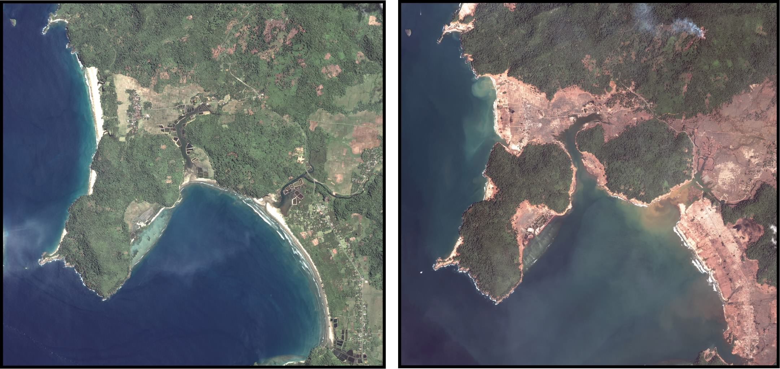

Figure 1. Satellite photos taken of northern Sumatra before (left) and after (right) the 2004 South Asia tsunami. Sand and mud (tan and brown colors) have traveled in most areas inundated by the tsunami, forming a marker horizon of this event. However, modification of this layer has already begun, as shown by sediment plumes washing into the ocean.

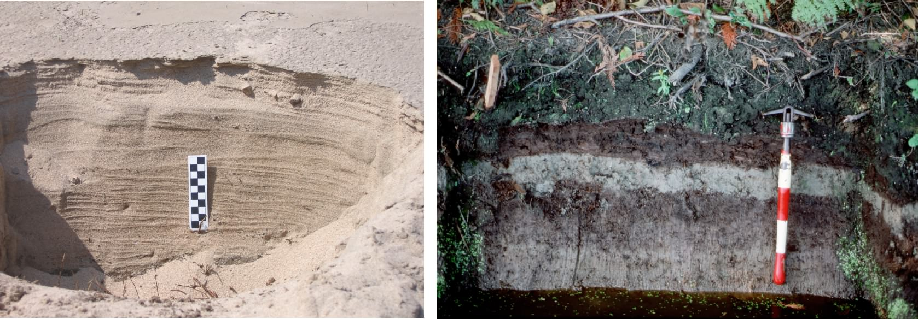

Figure 2. Complex internal stratigraphy from the 2004 South Asia tsunami (left) and simple internal stratigraphy from a 1000-year-old tsunami deposit in Puget Sound, Washington (right).

References:

Atwater, B.F., and Moore, A.L., 1992, A tsunami about 1000 years ago in Puget Sound, Washington: Science, v. 258, p. 1614-1617.
Benson, B.E., Grimm, K.A., and Clague, J.J., 1997, Tsunami deposits beneath tidal marshes on northwestern Vancouver Island, British Columbia: Quaternary Research, v. 48, p. 192-204.
Bourgeois, J., and Reinhart, M.A., 1993, Tsunami deposits from 1992 Nicaragua event: implications for interpretation of paleotsunami deposits, Cascadia subduction zone: Eos, Transactions, American Geophyiscal Union, v. 74, p. 350.
Bryant, E.A., Young, R.W., and Price, D.M., 1992, Evidence of tsunami sedimentation on the southeastern coast of Australia: Journal of Geology, v. 100, p. 753-765.
Chagué-Goff, C., and Goff, J.R., 1999, Geochemical and sedimentological signature of catastrophic saltwater inundations (tsunami), New Zealand: Quaternary Australasia, v. 17, p. 38-48.
Dawson, A.G., Long, D., and Smith, D.E., 1988, The Storegga Slides: evidence from eastern Scotland for a possible tsunami: Marine Geology, v. 82, p. 271-276.
Dawson, A.G., Shi, S., Dawson, S., Takahashi, T., and Shuto, N., 1996, Coastal sedimentation associated with the June 2nd and 3rd, 1994 tsunami in Rajegwesi, Java: Quaternary Science Reviews, v. 15, p. 901-912.
Gelfenbaum, G., and Jaffe, B., 2003, Erosion and Sedimentation from the 17 July, 1998 Papua New Guinea Tsunami: Pure and Applied Geophysics, v. 160, p. 1969-1999.
Hearty, P.J., 1997, Boulder deposits from large waves during the last interglaciation on North Eleuthera, Bahamas: Quaternary Research, v. 48, p. 326-338.
Moore, A., and Mohrig, D., 1994, Size estimate of a 1000-year-old Puget Sound tsunami [abstract]: GSA Abstracts with Programs, v. 26, p. 522.
Moore, A., Nishimura, Y., Gelfenbaum, G., Kamataki, T., and Triyono, R., in review, Sedimentary deposits of the 26 December 2004 tsunami on the northwest coast of Aceh, Indonesia: Earth, Planets, and Space.
Moore, A.L., 2000, Landward fining in onshore gravel as evidence for a late Pleistocene tsunami on Molokai, Hawaii: Geology, v. 28, p. 247-250.
Moore, J.G., Bryan, W.B., and Ludwig, K.R., 1994, Chaotic deposition by a giant wave, Molokai, Hawaii: Geological Society of America Bulletin, v. 106, p. 962-967.
Moore, J.G., and Moore, G.W., 1984, Deposit from a giant wave on the island of Lanai, Hawaii: Science, v. 226, p. 1312-1315.
Nanayama, F., Satake, K., Furukawa, R., Shimokawa, K., Atwater, B.F., Shigeno, K., and Yamaki, S., 2003, Unusually large earthquakes inferred from tsunami deposits along the Kuril trench: Nature, v. 424, p. 660-663.
Nanayama, F., Shigeno, K., Satake, K., Shimokawa, K., Koitabashi, S., Miyasaka, S., and Ishii, M., 2000, Sedimentary differences between the 1993 Hokkaido-nansei-oki tsunami and the 1959 Miyakojima typhoon at Taisei, southwestern Hokkaido, northern Japan: Sedimentary Geology, v. 135, p. 255-264.
Nott, J., 1997, Extremely high-energy wave deposits inside the Great Barrier Reef, Australia: determining the cause--tsunami or tropical cyclone: Marine Geology, v. 141, p. 193-207.
Pinegina, T.K., and Bourgeois, J., 2001, Historical and paleo-tsunami deposits on Kamchatka, Russia: long-term chronologies and long-distance correlations: Natural Hazards and Earth Systems Sciences, v. 1, p. 177-185.
Pinegina, T.K., Bourgeois, J., Bazanova, L.I., Melekestsev, I.V., and Braitseva, O.A., 2003, A millennial-scale record of Holocene tsunamis on the Kronotskiy Bay coast, Kamchatka, Russia: Quaternary Research, v. 59, p. 36-47.
Reinhart, M.A., 1991, Sedimentological analysis of postulated tsunami-generated deposits from Cascadia great-subduction earthquakes along southern coastal Washington: Seattle, WA, University of Washington.
Reinhart, M.A., and Bourgeois, J., 1989, Tsunami favored over storm or seiche for sand deposit overlying buried Holocene peat, Willapa Bay, WA: Eos, Transactions, American Geophyiscal Union, v. 70, p. 1331.
Tanioka, Y., and Satake, K., 2001, Detailed coseismic slip distribution of the 1944 Tonankai earthquake estimated from tsunami waveforms: Geophysical Research Letters, v. 28, p. 1075-1078.
Tuttle, M.P., Ruffman, A., Anderson, T., and Jeter, H., 2004, Distinguishing tsunami from storm deposits in eastern North America: the 1929 Grand Banks tsunami versus the 1991 Halloween storm: Seismological Research Letters, v. 75, p. 117-131.
Young, R.W., Bryant, E.A., and Price, D.M., 1996, Catastrophic wave (tsunami?) transport of boulders in southern New South Wales, Australia: Zeitschrift für Geomorphologie, v. 40, p. 191-207.

